INTRODUCTION

The Consumer Corner FuelX is a web-based platform designed to streamline gas cylinder bookings for consumers and enhance inventory management for suppliers. Many current systems rely on outdated technology, leading to inefficiencies and security risks. This project aims to modernize the process by offering a secure, user-friendly interface that automates booking, inventory tracking, and order fulfillment.

The responsive design ensures accessibility across devices, allowing consumers to easily register, book cylinders, and track orders without manual interventions, thus saving time. Suppliers benefit from efficient inventory management, order handling, and the ability to maintain accurate records, ensuring timely distribution.

With strong security measures, including encrypted transactions, the system protects sensitive information. Future enhancements may include mobile app integration, AI-driven demand forecasting, and IoT-enabled smart cylinders. Overall, this system offers a reliable, secure, and convenient solution for both consumers and suppliers in the gas distribution industry

2.SYSTEM STUDY AND ANALYSIS

2.1 EXISTING SYSTEM

The existing gas booking and distribution system is largely outdated and inefficient. It relies heavily on manual processes where consumers must book gas cylinders through phone calls or in-person visits. This often leads to delays, errors, and poor customer satisfaction. Suppliers face challenges with inventory management due to the lack of real-time tracking, resulting in difficulties in meeting consumer demand efficiently. Additionally, the system has significant security flaws, with consumer data vulnerable to breaches. The lack of automation, poor user interfaces, and the absence of real-time order tracking make the entire process cumbersome for both consumers and suppliers

2.2 PROPOSED SYSTEM

The proposed Consumer Corner FuelX addresses these challenges by implementing a modern, web-based solution that automates key functions such as gas cylinder bookings, payments, and inventory management. Consumers can now register, log in, and book cylinders online, while also tracking their orders in real time through a simple, intuitive interface. Suppliers benefit from improved inventory management, allowing them to keep track of stock levels and fulfill orders efficiently. The system is designed with enhanced security features to protect sensitive information and ensure safe transactions. This streamlined system not only improves the customer experience but also boosts operational efficiency, offering scalability for future technological advancements such as AI-based demand prediction and IoT integration for smart cylinders.

MODULE DESCRIPTION

1. CONSUMER

This module manages all aspects of consumer interactions with the system, ensuring a smooth experience for individuals booking gas cylinders. It allows consumers to securely register, log in, and manage their profiles, including personal information and addresses. Additionally, consumers can view and track their past and current bookings. Key functions include the ability to add new consumers to the system, update consumer profiles, and provide access to a booking history where users can review and track the status of their orders.

2. SUPPLIER

The supplier module helps gas suppliers efficiently manage their operations. Suppliers can register with the system and update their profiles, including their service areas and available inventory. This module also assists suppliers in managing their stock and fulfilling consumer orders. Suppliers can add or update information about their inventory and service offerings. The add supplier function allows new suppliers to be registered, while managing supplier profiles enables existing suppliers to update their information, monitor stock levels, and ensure timely deliveries. The inventory management feature tracks gas cylinder availability, helping suppliers meet consumer demand efficiently.

3. CATEGORIES

This module simplifies the process of organizing gas products into various categories for consumer selection. It ensures accurate classification and smooth management of products, such as different types of gas cylinders for domestic or commercial use. The system allows suppliers to add new categories for different gas products, ensuring that the platform remains up-to-date with the latest inventory. The manage categories function allows suppliers to update or remove existing categories as needed to reflect changes in product availability or specifications.
4. CYLINDER

The cylinder module tracks the lifecycle and status of individual gas cylinders. This module enables suppliers to keep a detailed record of each cylinder's availability, assignment, and condition. Using this module, suppliers can add new cylinders to the system, ensuring that each unit is properly documented. Additionally, the manage cylinders feature allows suppliers to update information about cylinders, such as their condition, availability, and consumer allocation. This ensures efficient cylinder management and minimizes the risk of lost or misplaced cylinders.

5. CONNECTIONS

This module manages gas connection requests from consumers, ensuring that each request is processed efficiently and accurately. Consumers can request new gas connections, and this module helps track the status of each request, whether approved, on hold, or rejected. The new connections function records all consumer requests for new gas connections, while the approved connections feature lists those that have been successfully processed and fulfilled. The system also includes functions to handle on-hold connections, which may require additional verification, and rejected connections, providing transparency on why a connection request was declined.

6. BOOKING

The core of the system, the booking module, handles all gas cylinder bookings from consumers. This module processes orders, tracks their status, and facilitates communication between consumers and suppliers. Consumers can easily place new orders through the add new booking function, which collects all the necessary details for the order. The manage booking feature allows consumers and suppliers to update or cancel existing orders, providing flexibility and real-time control over bookings. The order tracking functionality gives consumers insight into the status of their orders, from confirmation to delivery, ensuring transparency throughout the booking process.
FEASIBILITY STUDY

TECHNICAL FEASIBILITY

The system uses PHP for the frontend and MySQL for the backend, both well-established technologies. PHP provides a flexible and secure platform for user interfaces, while MySQL efficiently handles data management and scalability, ensuring reliable performance.

OPERATIONAL FEASIBILITY

The system automates gas booking and inventory management, improving efficiency and reducing manual errors. Its user-friendly interface ensures ease of use for both consumers and suppliers, allowing smooth integration into daily operations and improving service delivery.

ECONOMICAL FEASIBILITY

Using open-source tools like PHP and MySQL keeps development and maintenance costs low, making the system economically viable. The long-term benefits of operational efficiency and reduced manual work justify the initial investment

3.REQUIREMENT ANALYSIS

HARWARE SPECIFICATIONS
The section of hardware is very important for the proper functioning of any software, the size and capacity requirements are also important
The following hardware are needed for the development of the system

- INPUT DEVICE : Mouse , Keyboard
- OUTPUT DEVICE : Monitor
- MEMORY : 4GB RAM(Minimum)
- PROCESSOR : PENTIUM 4 PROCESSOR or above

SOFTWARE SPECIFICATIONS

- OPERATING SYSTEM : WINDOWS 7 or above
- IDE : VSCODE
- TOOLS : XAMPP

4. ABOUT THE SOFTWARE
Visual Studio is a powerful tool for developers, providing a wide range of features to support the entire software development lifecycle, from coding and debugging to testing and deployment. Its versatility and extensive capabilities make it a popular choice among developers in various fields. Visual Studio is an integrated development environment (IDE) developed by Microsoft. It is primarily used for developing applications and software across various platforms, including web, mobile, desktop, and cloud. Here are some key features of Visual Studio:

- Multi-Language Support: Supports multiple programming languages, including C#, C++, Visual Basic, JavaScript, Python, and more.
- Code Editor: Offers advanced code editing features such as syntax highlighting, IntelliSense (code completion suggestions), code refactoring, and code navigation tools.
- Debugging Tools: Integrated debugging tools allow developers to set breakpoints, inspect variables, and step through code, making it easier to identify and fix issues.
- Version Control Integration: Supports Git and other version control systems, allowing developers to manage code changes and collaborate with teams effectively.
- Integrated Development Frameworks: Comes with frameworks like .NET, ASP.NET, and Xamarin for building applications for various platforms, including web and mobile.
- Visual Designers: Provides designers for user interfaces, including Windows Forms, WPF (Windows Presentation Foundation), and web forms for rapid UI development
- Testing Tools: Includes unit testing and performance testing tools to ensure code quality and reliability.
- Extensions and Customization: Supports a wide range of extensions and plugins from the Visual Studio Marketplace, allowing developers to enhance functionality and customize their development environment.
- Azure Integration: Simplifies the deployment and management of applications on Microsoft Azure, allowing developers to create cloud-based applications easily.

- Project Templates: Offers various project templates for different types of applications, helping developers quickly set up new projects.
- Cross-Platform Development: Enables developers to create applications for Windows, macOS, Android, and iOS, making it versatile for multi-platform development.
- Collaboration Tools: Features tools like Live Share for real-time collaboration with team members, facilitating pair programming and code reviews.

FRONT END
HTML
HTML, or HyperText Markup Language, is the standard markup language used for creating and structuring content on the web. It serves as the backbone of web pages, allowing developers to define elements such as headings, paragraphs, links, images, and other multimedia content. HTML uses a system of tags, which are enclosed in angle brackets (e.g., <tagname>), to delineate different types of content and their roles within a document. The basic structure of an HTML document includes elements like <!DOCTYPE html>, <html>, <head>, and <body>, which together form the framework of a web page.
One of the key features of HTML is its ability to create hyperlinks, which allow users to navigate between different pages and websites seamlessly. This capability is fundamental to the interconnected nature of the web. Additionally, HTML supports a variety of media types, enabling the inclusion of images, audio, and video content within web pages. The language has evolved over time, with HTML5 introducing new elements and attributes that enhance multimedia support, semantic structuring, and improved user interactions.
HTML is inherently a static language, meaning that it describes the structure and layout of content rather than implementing dynamic behavior. To create interactive and dynamic web applications, HTML is often used in conjunction with other technologies like CSS (Cascading Style Sheets) for styling and JavaScript for scripting. Together, these technologies allow developers to create visually appealing and interactive user experiences. Despite its simplicity, mastering HTML is essential for anyone interested in web development, as it forms the foundation for understanding more complex web technologies.

CSS
CSS, or Cascading Style Sheets, is a fundamental technology used in web development to control the visual presentation of web pages. It allows developers to apply styles to HTML elements, enabling the separation of content from design. This separation is essential for maintaining and updating websites, as changes to the style can be made without altering the underlying HTML structure. By using CSS, developers can create visually appealing and consistent layouts across multiple web pages, enhancing the overall user experience.
One of the key features of CSS is its use of selectors, which target specific HTML elements for styling. Selectors can be based on element types, classes, IDs, and other attributes, allowing for precise control over which elements are affected by particular styles. For example, a class selector can style all elements with the same class, while an ID selector can uniquely style a single element. CSS properties define the specific style aspects that can be changed, such as colors, fonts, margins, and padding. This flexibility allows developers to customize the look and feel of a website to suit their design goals.
CSS also supports responsive design through the use of media queries, which enable developers to apply different styles based on the characteristics of the device being used, such as screen size and orientation. This capability is crucial in today’s multi-device environment, as it ensures that web content is accessible and visually appealing across desktops, tablets, and smartphones. Additionally, CSS offers advanced features like animations and transitions, allowing for dynamic visual effects that can enhance user interactions and engagement.
The CSS box model is another essential concept that describes how elements are rendered on a web page. Each element is represented as a rectangular box consisting of content, padding, border, and margin. Understanding the box model is vital for layout design, as it affects how space is allocated and how elements are positioned relative to one another.

JAVASCRIPT
JavaScript is a high-level, versatile programming language primarily used in web development. It allows developers to add interactive elements to websites, making them dynamic and responsive. Unlike static HTML and CSS, which define the structure and style of a webpage, JavaScript is responsible for adding behavior and functionality. This could range from simple tasks like responding to button clicks to more complex operations such as handling forms, animating elements, and fetching data from a server.
One of the key strengths of JavaScript is its ability to manipulate the Document Object Model (DOM), which represents the structure of a webpage. By modifying the DOM, JavaScript can update HTML content, change styles, and create or remove elements in real time, all without requiring a page reload. This makes it ideal for creating highly interactive and dynamic user interfaces.
JavaScript is also widely used for handling events such as clicks, scrolls, and keyboard inputs. By listening for these events, JavaScript can trigger specific functions in response, providing users with immediate feedback and a seamless experience. For example, it can validate form data before submission, making sure users fill out fields correctly, or it can show and hide elements based on user interaction.

BACKEND
PHP
PHP (Hypertext Preprocessor) is an open-source server-side scripting language that is widely used for web development. Initially created in 1994, it has evolved over time and is now one of the most popular languages for building dynamic websites. PHP is designed to work seamlessly with HTML, allowing developers to embed PHP code within HTML documents, making it easy to create web pages that can interact with databases and handle user input dynamically.
One of the standout features of PHP is its simplicity. It has a straightforward syntax that is easy for beginners to grasp, yet powerful enough for advanced developers to create complex applications. PHP code is executed on the server, and the result is sent back to the client in the form of HTML, which is then displayed by the browser. This server-side execution makes PHP well-suited for developing web applications where user input needs to be processed or where data from a database needs to be retrieved and displayed.
PHP also excels in database integration. It supports a wide range of databases such as MySQL, PostgreSQL, and SQLite, making it ideal for building database-driven applications. This capability allows PHP to be used in a variety of web projects, from simple personal websites to large-scale e-commerce platforms and content management systems.

Another key advantage of PHP is its cross-platform compatibility. PHP scripts can run on a wide variety of platforms, including Windows, macOS, Linux, and UNIX, without any changes. This flexibility, combined with PHP’s open-source nature, has led to widespread adoption and a vibrant community that continually contributes to its improvement.
Overall, PHP’s versatility, ease of use, and powerful database capabilities make it a popular choice for web development. It powers major platforms like WordPress and is commonly used for building dynamic websites and web applications.

5. SYSTEM DESIGN
E-R DIAGRAM
- A diagram that depicts a set of real-world entities and the logical relationships among them
- An E-R diagram comprises data objects, entities, attributes, relationships.

- Entities: It is the data that stores information about the system in a database.
- Attributes: It describes the properties of data object.
- Relationships: Connection of objects or entities with each other.

Four types of relationships:
- One to One Relationship: One instance of an entity is related to another instance of another instance.
- One to Many Relationship: One instance of an entity is related to several instance of an entity.
- Many to One Relationship: Many instance of an entity is related to one instance of an entity.
- Many to Many Relationship: Many instance of an entity is related to several instance of an entity.

5.1 E-R DIAGRAM NOTATIONS

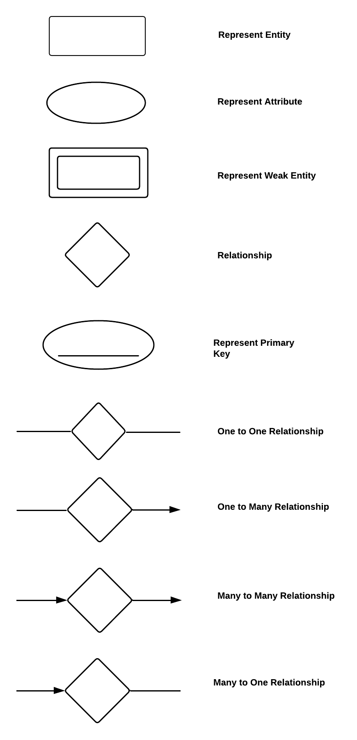


ER DIAGRAM

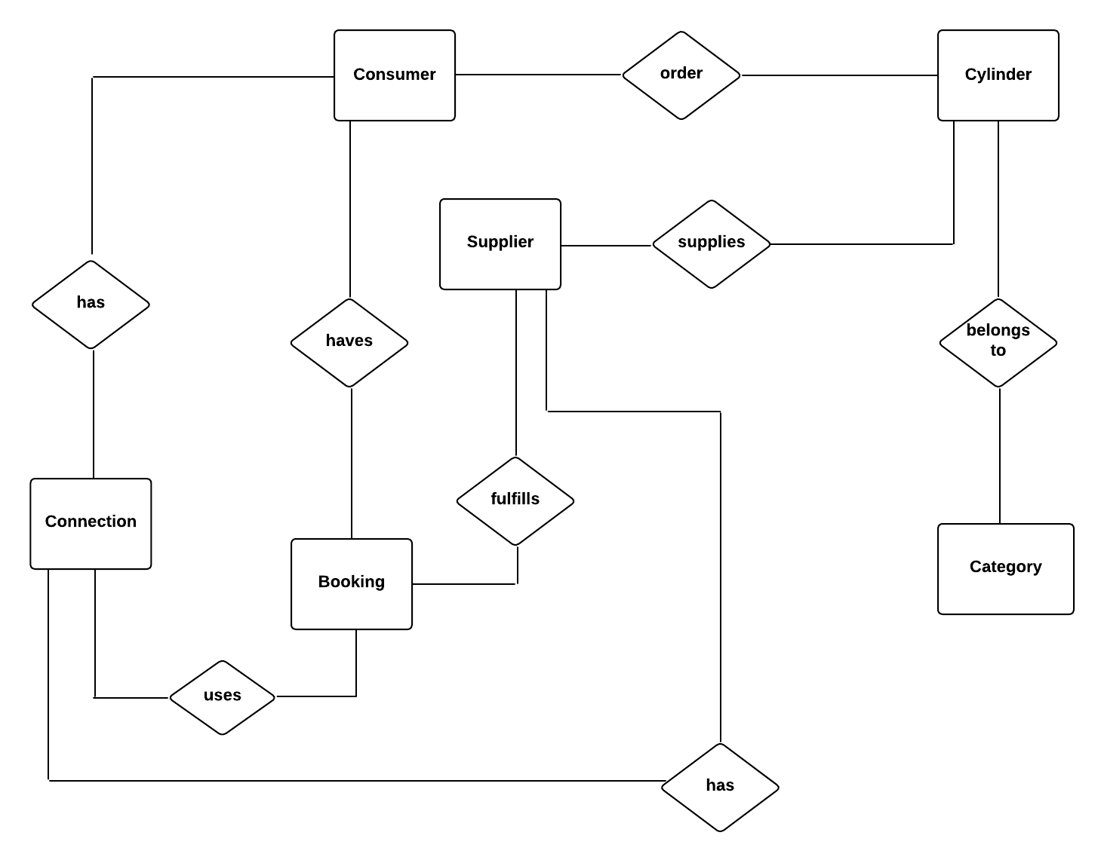

5.2. DATABASE DESIGN

INTRODUCTION
Design concepts provide the basic criteria for design quality. Design in the meaningful representation for something to build. Design focuses on three major areas of concern: data, architecture, interface beginning one the software requirement has been analyzed and specified.

INPUT DESIGN
Input design is a part of overall design, which requires careful attributes. Input design is a process of converting user oriented input into computer-based formats. This input to the system is provided using java. The goal of designing input data is to make entry as easy, logical and free from errors. Computers require necessary data for their functioning, hence input designs become an essential part of computer oriented information systems. The goal of de signing input data is to make data entry easy, logical and free from errors as possible. Inputs are raw data that are accepted from the system and are processed to produce the output. The input records have to be validated, edited, organized and accepted by the system before being processed to produce the output. We use some data entry screens for inputting different data. Input screens messages and careful programming can reduce input as errors to some extent.

OUTPUT DESIGN
Computer output is the most important and direct source of information to the user. Efficient, intelligible output design should improve the system's relationship with the user and help in the decision making. Outputs are important because it is the overall result of the effort spent on the work. Output design is the ongoing activity, started during the study phase itself. A major form of output is a hard copy from the printer. Output generally refers to the result and information data that are generated by the system. It can be in the form of operational documents and reports.
OBJECTIVES OF OUTPUT DESIGN
- To develop output design that serves the intended purpose and eliminates the production of unwanted output.
- To develop the output design that meets the end user’s requirements.
- To deliver the appropriate quantity of output.
- To form the output in appropriate format and direct it to the right person.
- To make the output available on time for making good decision

DATABASE DESIGN

BRANDS
COLUMN NAME | DATA TYPE | CONSTRAINTS | DESCRIPTION
brand_id | Int(11) | Primary Key | Brand id
brand_name | Varchar(255) | Not Null | Brand name
brand_active | Int(11) | Not Null | Brand active
brand_status | Int(11) | Not Null | Brand status

CATEGORIES
COLUMN NAME | DATA TYPE | CONSTRAINTS | DESCRIPTION
categories_id | Int(11) | Primary Key | Categories id
categories_name | Varchar(255) | Not Null | Categories name
categories_active | Int(11) | Not Null | Categories active
categories_status | Int(11) | Not Null | Categories status

MANAGE WEBSITE
COLUMN NAME | DATA TYPE | CONSTRAINTS | DESCRIPTION
Id | Int(11) | Primary Key | Id
Title | Varchar(600) | Not Null | Title
short_title | Varchar(600) | Not Null | Short title
Logo | text | Not Null | Logo
Footer | text | Not Null | Footer
currency_code | Varchar(600) | Not Null | Currency code
currency_symbol | Varchar(600) | Not Null | Currency symbol
login_logo | text | Not Null | Login logo
invoice_logo | text | Not Null | Invoice logo
background_login_image | text | Not Null | background_login_image

ORDERS
COLUMN NAME | DATA TYPE | CONSTRAINTS | DESCRIPTION
order_id | Int(11) | Primary Key | Order id
order_date | date | Not null | Order date
client_name | Varchar(255) | Not null | Client name
client_contact | Varchar(255) | Not null | Client contact
delivery_staff | Varchar(100) | Not null | Delivery staff
delivery_status | Varchar(100) | Not null | Delivery status
sub_total | Varchar(255) | Not null | Sub total
Vat | Varchar(255) | Not null | Vat
total_amount | Varchar(255) | Not null | Total amount
discount | Varchar(255) | Not null | Discount
grand_total | Varchar(255) | Not null | Grand total

ORDER ITEM
COLUMN NAME | DATA TYPE | CONSTRAINTS | DESCRIPTION
order_item_id | Int(11) | Primary Key | Order item id
order_id | Int(11) | Not Null | Order id
product_id | Int(11) | Not Null | Product id
quantity | Varchar(255) | Not Null | Quantity
Rate | Varchar(255) | Not Null | Rate
Total | Varchar(255) | Not Null | Total
order_item_status | Int(11) | Not Null | Order item status

USERS
COLUMN NAME | DATA TYPE | CONSTRAINTS | DESCRIPTION
user_id | Int(11) | Primary Key | User id
username | Varchar(255) | Not Null | Username
password | Varchar(255) | Not Null | Password
Email | Varchar(255) | Not Null | Email

PRODUCT
COLUMN NAME | DATA TYPE | CONSTRAINTS | DESCRIPTION
product_id | Int(11) | Primary Key | Product id
product_name | Varchar(255) | Not Null | Product name
product_image | text | Not Null | Product image
brand_id | Int(11) | Not Null | Brand id
categories_id | Int(11) | Not Null | Categories id
quantity | Varchar(255) | Not Null | Quantity
Rate | Varchar(255) | Not Null | Rate
Active | Int(11) | Not Null | Active
Status | Int(11) | Not Null | Status

TBL_CLIENT
COLUMN NAME | DATA TYPE | CONSTRAINTS | DESCRIPTION
Id | Int(11) | Primary Key | Id
Name | Varchar(150) | Not Null | Name
Gender | Varchar(150) | Not Null | Gender
mob_no | Varchar(150) | Not Null | Mob no
reffering | Varchar(150) | Not Null | Reffering
address | Varchar(250) | Not Null | Address
created_date_time | timestamp | Not Nul | Created date time
delete_status | Int(11) | Not Null | Delete status
Image | Varchar(150) | Not Null | Image
connection_no | Varchar(50) | Not Null | Connection no
Status | Tinyint(4) | Not Null | Status

TBL_EMAIL_CONFIG
COLUMN NAME | DATA TYPE | CONSTRAINTS | DESCRIPTION
e_id | Int(21) | Primary Key | E id
Name | Varchar(500) | Not Null | Name
mail_driver_host | Varchar(5000) | Not Null | Mail driver host
mail_port | Int(50) | Not Null | Mail port
mail_username | Varchar(50) | Not Null | Mail username
mail_password | Varchar(30) | Not Null | Mail password
mail_encrypt | Varchar(300) | Not Null | Mail encrypt

5.3 DATA FLOW DIAGRAM
A Data Flow Diagram (DFD) is a graphical representation used to illustrate the flow of data within a system. It focuses on how data moves between processes, data stores, and external entities, and it helps to visualize the system's functional aspects. DFDs are useful for understanding, analyzing, and improving systems in terms of data processing and flow. A DFD helps stakeholders and developers understand how data moves through the system without needing to dive into technical details like code or specific database structures. It is an essential tool for system analysis and design, making it easier to identify potential bottlenecks, inefficiencies, or missing data flows in a system.

Components of a DFD:
- External Entity: Represents people, organizations, or other systems that interact with the system (e.g., customers, suppliers).
- Process: Shows how data is processed (e.g., calculations, data transformations, or decision-making).
- Data Store: Where data is stored within the system (e.g., databases, files).
- Data Flow: Shows the movement of data between processes, entities, and data stores.
Levels of DFD
- Level 0 (Context Diagram): The highest level DFD which provides an overview of the system and how it interacts with external entities.
- Level 1: Breaks down the major processes from the context diagram into more detailed sub-processes.
- Level 2 and beyond: Further decompose the processes for a detailed analysis of the system's workings.

LEVEL:0

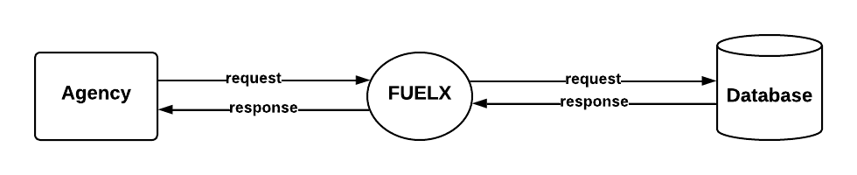

LEVEL:1

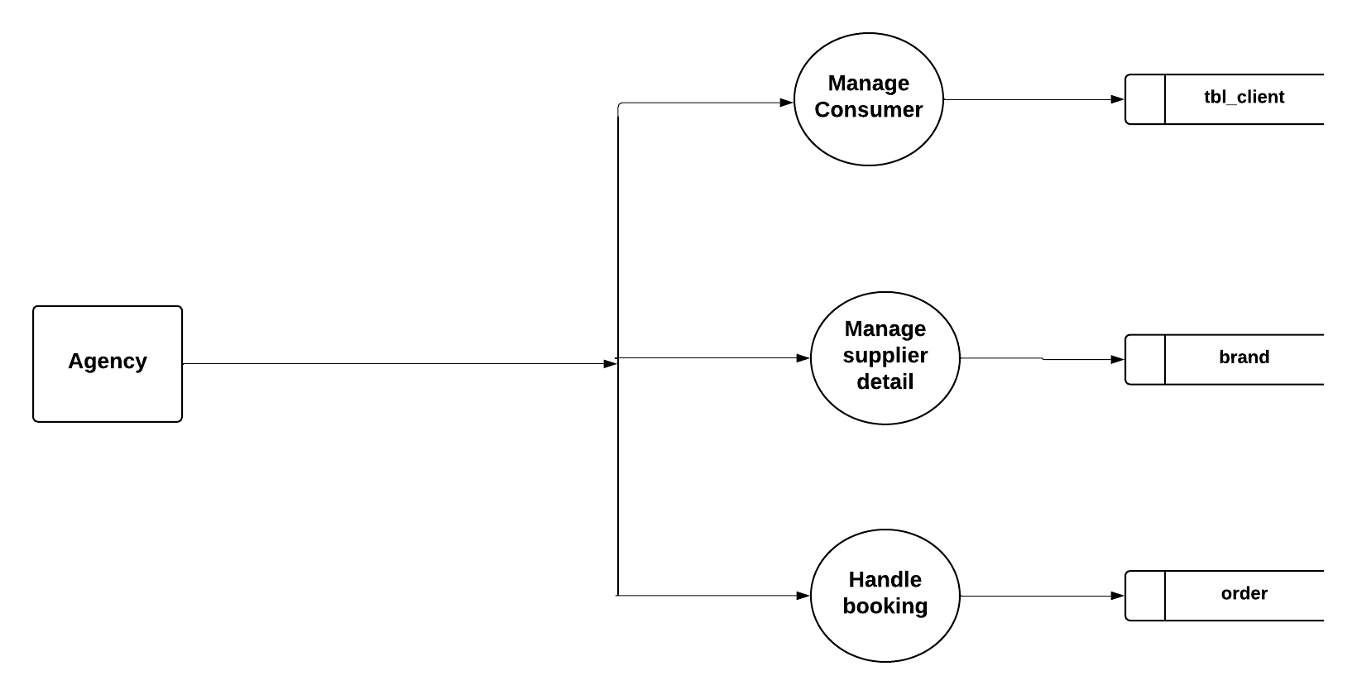

LEVEL:2

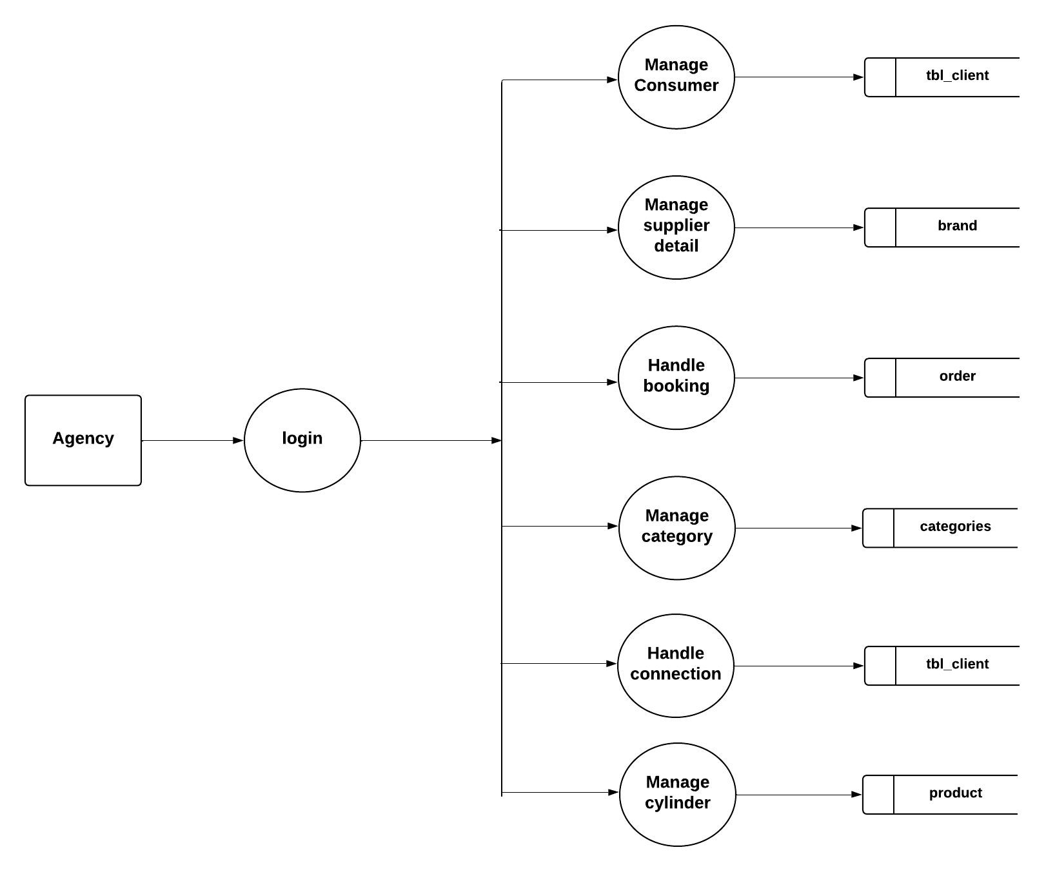

  - AGILE METHODOLOGY
After the initial studies it is found that agile model of software development is suitable and is the best method for the development of this system. Agile methodology mainly focused on the client satisfaction through continuous delivery. Also, it sets a minimum number of requirements and turns them in to a deliverable product. As this project has many individual requirements which can be delivered in parts and the user can gradually improve their work efficiency. Agile methodology has a family of methods of which scrum is selected for the development of this project. Scrum is process framework that has been used to manage complex product development. It is not a process or technique for building products rather it is a framework within which various processes can be employed. Also, it is suitable method to support the development process. It focuses on lean software development and has in building better software effectively and efficiently. Agile is one of the most widely used and recognized software development frameworks. The methodology those experts agreed upon was described as ‘lightweight’ and fast. Agile is also about being the adaptive and continuous improvement, as much as it is about constant feedback and speed of delivery. Agile is a software development approach where a self-sufficient and cross-functional team works on making continuous deliveries through iterations and evolves throughout the process by gathering feedback from the end users. The major rules in scrum methodology are
- Product owner (PO): Who represents the stake holder and the business.
- The scrum master: Ensures the process followed, removes obstructions, and protects the development system.
- Development team: Cross functional, self-organizing team who actually do the actual analysis, design implementation and testing process. They work together in iterative time boxed durations called sprints. The first step is the creation of the product backlog by the PO. It’s a to-do list of stuff to be done by the scrum team. Then the scrum team selects the top priority items and tries to finish them within the time box called a sprint. An easier way to remember all of this is to memorize the 3-3-5 frame-work. It means that a scrum project has 3 roles, 3artifacts, and 5 events These are:-
1. Roles: Product Owner, Scrum Master, and development team.
2. Artifacts: Product Backlog, Sprint Backlog and Product Increment.
3. Events: Sprint, Sprint planning, Daily Scrum, Sprint review and Sprint retrospective
The framework begins with a simple premise start with what can be seen or known. After that the progress is tracked and tweak as necessary. The three pillars of scrum are transparency, inspection and adaptation. In scrum everyone has a role. Git is used as the version control system for this project. Version control is a system that record changes to a file or set of files over time so that a specific version can be recalled later. Version control system are a category of software tools that helps a software team for managing changes to source code over time.
User Story:
A user story is a tool used in agile software development to capture a description of software feature from an end-user perspective. The user story describes the type of user, what they want and why. A user story helps to create a simplified description of a requirement.

User Story ID | As a <Type of user> | I want to perform  <some task> | So that I can  <achieve some goal>
1 | USER, AGENCY | Login | Access the account
2 | USER, AGENCY | Booking cylinder | Enter Details
3 | USER | Payment | Get Result
4 | USER | Profile | Status View
user story

PRODUCT BACKLOG
A product backlog is a list of the new features, changes to existing features, bug fixes, infrastructure changes or other activities that a team may deliver in order to achieve a specific outcome. The product backlog is the single authoritative source for things that a team works on. That means that nothing gets done that isn’t on the product backlog. Conversely, the presence of a product backlog item on a product backlog does not guarantee that it will be delivered. It represents an option the team has for delivering a specific outcome rather than a commitment. It should be cheap and fast to add a product back log item to the product backlog, and it should be equally as easy to remove a product backlog item that does not result in direct progress to achieving the desired outcome or enable progress toward the outcome. The Scrum Product Backlog is simply a list of all things that needs to be done within the project. It replaces the traditional requirements specification artifacts. These items can have a technical nature or can be user-centric e.g., in the form of user stories.
The product backlog of the system is given

PRODUCT BACKLOG
 | Name | Priority | Estimate[Hrs]
1 | Login | 1 | 6
2 | Booking | 2 | 10
3 | Payment | 3 | 12
4 | Profile Update | 4 | 12

Product Backlog

PROJECT PLAN
A project plan that has a series of tasks laid out for the entire project, listing task duration durations, responsibility assignments, and dependencies. Plans are developed in this manner based on the assumption that the Project Manager, hopefully along with the team, can predict up front everything that will need to happen in the project, how long it will take, and who will be able to do it. Project plan is given in below
User story ID | Task Name | Start Date | End Date | Days | Status
Sprint 1 |  | 31/07/2024 | 17/08/2024 | 3 | Completed
1 | Login | 31/07/2024 | 31/07/2024 | 1 | Completed
2 | Coding | 07/08/2024 | 14/08/2024 | 1 | Completed
3 | Testing | 17/08/2024 | 17/08/2024 | 1 | Completed
Sprint 2 |  | 21/08/2024 | 07/08/2024 | 5 | Completed
4 | Booking | 21/08/2024 | 21/08/2024 | 1 | Completed
5 | Coding | 31/08/2024 | 04/09/2024 | 3 | Completed
6 | Testing | 07/09/2024 | 07/09/2024 | 1 | Completed
Sprint 3 |  | 11/09/2024 | 05/09/2024 | 4 | Completed
7 | Database Connectivity | 11/09/2024 | 25/09/2024 | 2 | Completed
8 | Payment | 28/09/2024 | 28/09/2024 | 1 | Completed
9 | Profile Update | 05/10/2024 | 05/10/2024 | 1 | Completed
Sprint 4 |  | 09/10/2024 | 19/10/2024 | 3 | Completed
11 | Deployment | 09/10/2024 | 09/10/2024 | 1 | Completed
12 | Testing and Validation | 16/10/2024 | 19/10/2024 | 2 | Completed

The Project has four sprints:
- Sprint 1
Three tasks are planned in this sprint. First one is login, coding and testing.
- Sprint 2
Three tasks are planned in this sprint. First one is registration, coding and testing.
- Sprint 3
Three tasks are planned in this sprint. These are database connectivity and development of web user interface using PHP and Integration of MY SQL SERVER.
- Sprint 4
In this sprint two tasks are planned to completed, one is Deployment of web app testing and validation.

Sprint Backlog (Plan)
The sprint backlog is a list of tasks identified by the Scrum team to be completed during the Scrum sprint. During the sprint planning meeting, the team selects some number of product back log items, usually in the form of user stories, and identifies the tasks necessary to complete each user story. Most teams also estimate how many hours each task will take someone on the team to complete.
Sprint 1:
Three tasks are planned in this sprint. First one is login, next is initial coding and testing. Sprint backlog (planning) for sprint 1
Sprint 2:
Three tasks are planned in this sprint. First one is registration and next one is coding and testing. Sprint backlog (planning) for sprint 2

Sprint 3:
Three tasks are planned in this sprint. These are database connectivity and development of web user interface using PHP and Integration of MY SQL SERVER. The sprint backlog for sprint 3
Sprint 4:
In this sprint two tasks are planned to completed, one is Deployment of web app testing and validation. The sprint backlog for sprint 4.

Back log item | Com pletion time | Origi nal esti mate in ho urs | Day 1 | Day 2 | Day 3 | Day 4 | Day 5 | Day 6 | Day 7 | Day 8 | Day 9 | Day 10 | Day 11 | Day 12 | Day 13 | Day 14 | Day 15
User Story Hours |  |  | ho urs | ho urs | ho urs | ho urs | ho urs | ho urs | ho urs | ho urs | ho urs | ho urs | ho urs | ho urs | ho urs | ho urs | ho urs
Login | 31/07/ 24 | 2 | 2 | 0 | 0 | 0 | 0 | 0 | 0 | 0 | 0 | 0 | 0 | 0 | 0 | 0 | 0
Coding | 14/08/24 | 2 | 0 | 2 | 0 | 0 | 0 | 0 | 0 | 0 | 0 | 0 | 0 | 0 | 0 | 0 | 0
Testing | 17/08/24 | 2 | 0 | 0 | 2 | 0 | 0 | 0 | 0 | 0 | 0 | 0 | 0 | 0 | 0 | 0 | 0
Total |  | 6 | 2 | 2 | 2 | 0 | 0 | 0 | 0 | 0 | 0 | 0 | 0 | 0 | 0 | 0 | 0

Sprint Backlog (Plan)-Sprint 1

Back log item | Cm ple tion tim e | Origi nal esti mate in ho urs | Day 1 | Day 2 | Day 3 | Day 4 | Day 5 | Day 6 | Day 7 | Day 8 | Day 9 | Day 10 | Day 11 | Day 12 | Day 13 | Day 14 | Day  15
Use r Story #1 Ho urs |  |  | ho ur s | ho ur s | ho ur s | ho ur s | ho ur s | ho ur s | ho ur s | ho ur s | ho ur s | ho ur s | ho ur s | ho ur s | ho ur s | ho ur s | Hour  s
Booking | 21/8/ 24 | 2 | 0 | 0 | 0 | 2 | 0 | 0 | 0 | 0 | 0 | 0 | 0 | 0 | 0 | 0 | 0
Coding | 04/09/ 24 | 6 | 0 | 0 | 0 | 0 | 2 | 2 | 2 | 0 | 0 | 0 | 0 | 0 | 0 | 0 | 0
Testing | 19/08/24 | 2 | 0 | 0 | 0 | 0 | 0 | 0 | 0 | 2 | 0 | 0 | 0 | 0 | 0 | 0 | 0
Total |  | 10 | 0 | 0 | 0 | 2 | 2 | 2 | 2 | 2 | 0 | 0 | 0 | 0 | 0 | 0 | 0

Sprint Backlog (Plan)-Sprint2

Back log item | Cm ple tion time | Origi nal esti mate in ho urs | Day 1 | Day 2 | Day 3 | Day 4 | Day 5 | Day 6 | Day 7 | Day 8 | Day 9 | Day 10 | Day 11 | Day 12 | Day 13 | Day 14 | Day 15
Use r Story #1 Ho urs |  |  | ho ur s | ho ur s | ho ur s | ho ur s | ho ur s | ho ur s | ho ur s | ho ur s | ho ur s | ho ur s | ho ur s | ho ur s | ho ur s | ho ur s | Hour s
Database Connectivity | 25/09/24 | 4 | 0 | 0 | 0 | 0 | 0 | 0 | 0 | 0 | 2 | 2 | 0 | 0 | 0 | 0 | 0
Payment | 28/09/ 24 | 2 | 0 | 0 | 0 | 0 | 0 | 0 | 0 | 0 | 0 | 0 | 2 | 0 | 0 | 0 | 0
Profile Update | 05/09/24 | 2 | 0 | 0 | 0 | 0 | 0 | 0 | 0 | 0 | 0 | 0 | 0 | 2 | 0 | 0 | 0
Total |  | 8 | 0 | 0 | 0 | 0 | 0 | 0 | 0 | 0 | 2 | 2 | 2 | 2 | 0 | 0 | 0

Sprint Backlog (Plan)-Sprint3

Back log item | Cm ple tion tim e | Origi nal esti mate in ho urs | Day 1 | Day 2 | Day 3 | Day 4 | Day 5 | Day 6 | Day 7 | Day 8 | Day 9 | Day 10 | Day 11 | Day 12 | Day 13 | Day 14 | Day 15
Use r Story #1 Ho urs |  |  | ho ur s | ho ur s | ho ur s | ho ur s | ho ur s | ho ur s | ho ur s | ho ur s | ho ur s | ho ur s | ho ur s | ho ur s | ho ur s | ho ur s | ho ur s
Deployment | 09/10/ 24 | 2 | 0 | 0 | 0 | 0 | 0 | 0 | 0 | 0 | 0 | 0 | 0 | 1 | 1 | 0 | 0
Test &Validation | 19/10/24 | 4 | 0 | 0 | 0 | 0 | 0 | 0 | 0 | 0 | 0 | 0 | 0 | 0 | 0 | 2 | 2
Total |  | 6 | 0 | 0 | 0 | 0 | 0 | 0 | 0 | 0 | 0 | 0 | 0 | 1 | 1 | 2 | 2

Sprint Backlog (Plan)-Sprint4

Sprint Backlog (Actual)

Actual sprint backlog is what adequate sprint planning is actually done by project team there may or may not be difference in planned sprint backlog. The detailed sprint backlog(Actual)is given below

Back log item | Com pletion time | Origi nal esti mate in ho urs | Day 1 | Day 2 | Day 3 | Day 4 | Day 5 | Day 6 | Day 7 | Day 8 | Day 9 | Day 10 | Day 11 | Day 12 | Day 13 | Day 14 | Day 15
User Story Hours |  |  | ho urs | ho urs | ho urs | ho urs | ho urs | ho urs | ho urs | ho urs | ho urs | ho urs | ho urs | ho urs | ho urs | ho urs | ho urs
Login | 31/07/ 24 | 2 | 2 | 0 | 0 | 0 | 0 | 0 | 0 | 0 | 0 | 0 | 0 | 0 | 0 | 0 | 0
Coding | 14/08/24 | 2 | 0 | 2 | 0 | 0 | 0 | 0 | 0 | 0 | 0 | 0 | 0 | 0 | 0 | 0 | 0
Testing | 17/08/24 | 2 | 0 | 0 | 2 | 0 | 0 | 0 | 0 | 0 | 0 | 0 | 0 | 0 | 0 | 0 | 0
Total |  | 6 | 2 | 2 | 2 | 0 | 0 | 0 | 0 | 0 | 0 | 0 | 0 | 0 | 0 | 0 | 0
Sprint Backlog (Actual)-Sprint 1
Back log item | Cm ple tion tim e | Origi nal esti mate in ho urs | Day 1 | Day 2 | Day 3 | Day 4 | Day 5 | Day 6 | Day 7 | Day 8 | Day 9 | Day 10 | Day 11 | Day 12 | Day 13 | Day 14 | Day  15
Use r Story #1 Ho urs |  |  | ho ur s | ho ur s | ho ur s | ho ur s | ho ur s | ho ur s | ho ur s | ho ur s | ho ur s | ho ur s | ho ur s | ho ur s | ho ur s | ho ur s | Hour  s
Booking | 21/8/ 24 | 2 | 0 | 0 | 0 | 2 | 0 | 0 | 0 | 0 | 0 | 0 | 0 | 0 | 0 | 0 | 0
Coding | 04/09/ 24 | 6 | 0 | 0 | 0 | 0 | 2 | 2 | 2 | 0 | 0 | 0 | 0 | 0 | 0 | 0 | 0
Testing | 19/08/24 | 2 | 0 | 0 | 0 | 0 | 0 | 0 | 0 | 2 | 0 | 0 | 0 | 0 | 0 | 0 | 0
Total |  | 10 | 0 | 0 | 0 | 2 | 2 | 2 | 2 | 2 | 0 | 0 | 0 | 0 | 0 | 0 | 0

Sprint Backlog (Actual)-Sprint2

Back log item | Cm ple tion time | Origi nal esti mate in ho urs | Day 1 | Day 2 | Day 3 | Day 4 | Day 5 | Day 6 | Day 7 | Day 8 | Day 9 | Day 10 | Day 11 | Day 12 | Day 13 | Day 14 | Day 15
Use r Story #1 Ho urs |  |  | ho ur s | ho ur s | ho ur s | ho ur s | ho ur s | ho ur s | ho ur s | ho ur s | ho ur s | ho ur s | ho ur s | ho ur s | ho ur s | ho ur s | Hour s
Database Connectivity | 25/09/24 | 4 | 0 | 0 | 0 | 0 | 0 | 0 | 0 | 0 | 2 | 2 | 0 | 0 | 0 | 0 | 0
Payment | 28/09/ 24 | 2 | 0 | 0 | 0 | 0 | 0 | 0 | 0 | 0 | 0 | 0 | 2 | 0 | 0 | 0 | 0
Profile Update | 05/09/24 | 2 | 0 | 0 | 0 | 0 | 0 | 0 | 0 | 0 | 0 | 0 | 0 | 2 | 0 | 0 | 0
Total |  | 8 | 0 | 0 | 0 | 0 | 0 | 0 | 0 | 0 | 2 | 2 | 2 | 2 | 0 | 0 | 0

Sprint Backlog (actual)-Sprint3

Back log item | Cm ple tion tim e | Origi nal esti mate in ho urs | Day 1 | Day 2 | Day 3 | Day 4 | Day 5 | Day 6 | Day 7 | Day 8 | Day 9 | Day 10 | Day 11 | Day 12 | Day 13 | Day 14 | Day 15
Use r Story #1 Ho urs |  |  | ho ur s | ho ur s | ho ur s | ho ur s | ho ur s | ho ur s | ho ur s | ho ur s | ho ur s | ho ur s | ho ur s | ho ur s | ho ur s | ho ur s | ho ur s
Deployment | 09/10/ 24 | 2 | 0 | 0 | 0 | 0 | 0 | 0 | 0 | 0 | 0 | 0 | 0 | 1 | 1 | 0 | 0
Test &Validation | 19/10/24 | 4 | 0 | 0 | 0 | 0 | 0 | 0 | 0 | 0 | 0 | 0 | 0 | 0 | 0 | 2 | 2
Total |  | 6 | 0 | 0 | 0 | 0 | 0 | 0 | 0 | 0 | 0 | 0 | 0 | 1 | 1 | 2 | 2

Sprint Backlog (Actual)-Sprint4

  - PRODUCT BACKLOG

REVIEW FORM

Sprint 1

Version: 1.0 Date:31-07-2024
User Story ID | Comments from Scrum master if any | Comments from Product Owner if any
1 | Developer should have a easy registration process | User friendly registration
2 | effective login | if there is forgot password or username handled.

Product Backlog Review (Sprint1)

Sprint 2

Version: 1.0 Date:21-08-2024
User Story ID | Comments from Scrum master if any | Comments from Product Owner if any
3 | User should have a easy registration process | User friendly registration
4 | effective login | if there is forgot password or username handled.

Product Backlog Review (Sprint2)

Sprint 3

Version: 1.0 Date:11-09-2024
User Story ID | Comments from Scrum master if any | Comments from Product Owner if any
5 | should check the data inserted correctly | inserted
6 | Design and development of registration forms | Should customize different mode

Product Backlog Review (Sprint3)

Sprint 4

Version: 1.0 Date:09-10-2024
User Story ID | Comments from Scrum master if any | Comments from Product Owner if any
7 | should check database connectivity | Check connection
8 | Booking | Enter Details.

Product Backlog Review (Sprint4)

7.1 SPRINT REVIEW
At the end of each sprint a Sprint Review meeting is held. During this meeting the Scrum Team shows which Scrum Product Backlog items they completed (according to the Definition of Done) during the sprint. This might take place in the form of a demo of the new features. Backlog items that are not completed shall not be demonstrated. Otherwise this might suggest that these items are finished as well. Instead incomplete items/remaining activities shall be taken back into the Scrum Product Backlog, re-estimated and completed in one of the following sprints. The Sprint Review meeting should be kept very informal. No Power Point slides should be used and time for preparation and performing the meeting should be limited. During the meeting the Scrum Product Owner inspects the implemented backlog entries and accepts the solution or adds new stories to the Scrum Product Backlog to adapt the functionality. Participants in the sprint review typically include the Scrum Product Owner, the Scrum Team and the Scrum Master. Additionally management, customers, and developers from other projects might participate as well.

REVIEW FORM

Sprint 1

Version: 1.0 Date:31-07-2024
User Story ID | Comments from Scrum master if any | Comments from Product Owner if any
1 | Developer should have a easy registration process | Satisfied
2 | effective login | Successful.

Sprint Review (Sprint1)

Sprint 2

Version: 1.0 Date:21-08-2024
User Story ID | Comments from Scrum master if any | Comments from Product Owner if any
3 | User should have a easy booking process | Satisfied
4 | effective login | Successful.

Sprint Review (Sprint2)

Sprint 3

Version: 1.0 Date:11-09-2024
User Story ID | Comments from Scrum master if any | Comments from Product Owner if any
5 | Should check database connectivity | Correctly Successful
6 | Should check the payment functions | Satisfied.

Sprint Review (Sprint3)

Sprint 4

Version: 1.0 Date:09-10-2024
User Story ID | Comments from Scrum master if any | Comments from Product Owner if any
7 | Deployment | Connection successful
8 | Result Generated | Successful

Sprint Review (Sprint4)
8. TESTING AND VALIDATION

Sprint 1
Version: 1.0 Date: 31-07-2024
Test # | Date | Action | Expected Result | Actual Result | Pass ?  <Yes/no>
1 | 31/07/2024 | Registration | Registration successful | Successful | Yes
2 | 02/08/2024 | Login | Login to system | Login to successful | Yes

Testing and Validation (Sprint1)

Sprint 2
Version: 1.0 Date: 21-08-2024
Test # | Date | Action | Expected Result | Actual Result | Pass ?  <Yes/no>
3 | 12/08/2024 | Login | Login to system | Successful | Yes
4 | 14/08/2024 | Booking | Booking | Login to successful | Yes

Testing and Validation(Sprint2)

Sprint 3
Version: 1.0 Date: 11-09-2024
Test # | Date | Action | Expected Result | Actual Result | Pass ?  <Yes/no>
5 | 24/08/2024 | Development of models | Can choose the best models | Done | Yes

Testing and Validation(Sprint3)

Sprint 4
Test # | Date | Action | Expected Result | Actual Result | Pass ?  <Yes/no>
6 | 30/09/2024 | Deployment | Successfully | Done | Yes
7 | 08/10/2024 | Result generated | Successfully | Done | Yes
Version: 1.0 Date: 30-09-2024

Testing and Validation(Sprint4)

9. CONCLUSION AND FUTURE SCOPE
It has been a great pleasure for us to work on this exciting and challenging project. This project proved good for us as it provided practical knowledge of programming in PHP and MYSQL server. It also provided knowledge about the latest technology used in web enabled application and client server technology that will be great demanding. This Consumer Corner FuelX enables agency to register users online, use and manage the booking of cylinder. Consumer Corner FuelX has been designed and developed according to the current requirements of a Gas Agency. The benefit expected from this is that it could reduce the burden of traditional method. The major goal of the software is to creates software that could automate all Gas Agency Related tasks.
This software is very helpful to users who are searching for software for automating a Gas Agency. The proposed Consumer Corner FuelX can provide an ultimate solution to many problems of gas agencies regarding gas distribution, order receiving, providing home delivery service, etc. As the implementation of project reduces the number of worker and use of paper, it is economical to use and has a good scope. New features, modules and functions can be incorporated into this system as per user requirements.

FUTURE SCOPE
The future scope of the "Consumer Corner FuelX" are :

- Integration with IoT Devices : Implement smart gas meters and sensors to monitor real-time usage and automate the reordering process, providing customers with seamless service and minimizing gas outages.

- Mobile App Expansion : Develop a mobile application to give users direct access to booking, tracking, and payment systems, making the process more user-friendly and expanding the platform to mobile-first customers.

- AI-Based Demand Forecasting : Utilize machine learning algorithms to predict gas demand based on historical data and external factors, improving inventory management and reducing shortages.

- Multiple Payment Options : Integrate various secure payment gateways, allowing customers to choose from more payment methods, including digital wallets, UPI, and crypto currencies for ease and flexibility.

- Multi-Location Support : Expand the system to handle multiple gas agencies or locations, creating a networked booking and distribution system that scales to serve a broader geographic area.

- Real-Time Delivery Tracking : Add real-time GPS tracking for delivery trucks, giving customers visibility on delivery status and improving customer satisfaction.

- Environmental Impact Analysis : Incorporate features to monitor and report on the environmental footprint of gas consumption, offering insights and suggestions for energy-efficient practices.

10. BIBLIOGRAPHY
- firebase:https://firebase.google.com/docs/auth/android/start
- Clean Code: A Handbook of Agile Software Craftsmanship is a book written by Robert. C. Martin. The writer brings Agile principles from a practitioner’s point of view of thousands of programmers.
- https://www.esri.com/en-us/industries/gas/overview
- https://sspinnovations.com/blog/esri-gas-distribution-data-management-for-arcgis-online-part-2/
- https://www.ge.com/digital/applications/smallworld-gis-geospatial-asset-management/gas-distribution-office
- Database System Concept Seventh Edition Avi Silberschatz Face The Real World of DatabaseSystems Fully Equipped.
- Learning PHP, MySQL & JavaScript: With jQuery, CSS & HTML5 is a book written by RobinNixon. The book helps you to build interactive, data-driven websites. In this edition, you’ll alsostudy dynamic web programming with the latest versions, PHP, MySQL, JavaScript, CSS.
- Database System: Design, Implementation, and Management 10th Edition (Strayer University)byCarlos Coronel, Steven Morris, Peter Rob.

11. SOURCE CODE

<?php error_reporting(1); ?>
<?php include('./constant/layout/head.php');?>
<?php include('./constant/layout/header.php');?>
<?php include('./constant/layout/sidebar.php');?>
<?php
$sql = "SELECT * FROM product WHERE status = 1";
$query = $connect->query($sql);
$countProduct = $query->num_rows;
$orderSql = "SELECT * FROM orders WHERE order_status = 1";
$orderQuery = $connect->query($orderSql);
$countOrder = $orderQuery->num_rows;
$totalRevenue = 0;
while ($orderResult = $orderQuery->fetch_assoc()) {
//echo $orderResult['paid'];exit;
$totalRevenue += $orderResult['paid'];
}
$lowStockSql = "SELECT * FROM product WHERE quantity <= 3 AND status = 1";
$lowStockQuery = $connect->query($lowStockSql);
$countLowStock = $lowStockQuery->num_rows;
$userwisesql = "SELECT tbl_client.name , SUM(orders.grand_total) as totalorder,order_id FROM orders INNER JOIN tbl_client ON orders.client_name = tbl_client.id WHERE orders.order_status = 1 GROUP BY orders.client_name";
$userwiseQuery = $connect->query($userwisesql);
$userwieseOrder = $userwiseQuery->num_rows;
$connect->close();
?>
<style type="text/css">
.ui-datepicker-calendar {
display: none;
}
</style>
<div class="page-wrapper">
<div class="row page-titles">
<div class="col-md-12 align-self-center">
</div>
</div>
<div class="container-fluid">
<div class="row">
<div class="col-md-3 dashboard">
<div class="card" style="background: #2BC155">
<div class="media widget-ten">
<div class="media-left meida media-middle">
<span><i class="mdi mdi-gas-cylinder f-s-50"></i></span>
</div>
<div class="media-body media-text-right">

<h2 class="color-white"><?php echo $countProduct; ?></h2>
<a href="product.php"><p class="m-b-0">Total Cylinder</p></a>
</div>
</div>
</div>
</div>
<?php if(isset($_SESSION['userId']) && $_SESSION['userId']==1) { ?>
<div class="col-md-3 dashboard">
<div class="card" style="background:#A02CFA ">
<div class="media widget-ten">
<div class="media-left meida media-middle">
<span><i class="ti-user f-s-40"></i></span>
</div>
<div class="media-body media-text-right">
<h2 class="color-white"><?php echo 3 ?></h2>
<a href="#"><p class="m-b-0">Total Suppliers</p></a>
</div>
</div>
</div>
</div>
<?php }?>
<?php if(isset($_SESSION['userId']) && $_SESSION['userId']==1) { ?>
<div class="col-md-3 dashboard">
<div class="card" style="background-color: #F94687 ">
<div class="media widget-ten">
<div class="media-left meida media-middle">
<span><i class="ti-vector f-s-40"></i></span>
</div>
<div class="media-body media-text-right">
<h2 class="color-white"><?php echo $countOrder; ?></h2>
<a href="Order.php"><p class="m-b-0">Total Booking</p></a>
</div>
</div>
</div>
</div>
<?php }?>
<div class="col-md-3 dashboard">
<div class="card" style="background-color:#009688;">
<div class="media widget-ten">
<div class="media-left meida media-middle">
<span><i class="ti-credit-card f-s-40"></i></span>
</div>
<div class="media-body media-text-right">
<h2 class="color-white"><?php if($totalRevenue) {
echo $totalRevenue;
} else {
echo '0';
} ?></h2>
<a href="Order.php"><p class="m-b-0">Total Revenue</p></a>
</div>
</div>
</div>
</div>
<?php if(isset($_SESSION['userId']) && $_SESSION['userId']==1) { ?>
<div class="col-md-12">
<div class="card">
<div class="card-header">
<strong class="card-title">User Wise Booking</strong>
</div>
<table class="table table-bordered table-striped">
<thead>
<tr>
<th scope="col">Name</th>
<!-- <th scope="col">Measurement</th> -->
<th scope="col">Booking Amount</th>
</tr>
</thead>
<tbody>
<?php while ($orderResult = $userwiseQuery->fetch_assoc()) { ?>
<tr>
<td><?php echo $orderResult['name']?></td>
<!-- <td><a href="viewMeasurement.php?id=<?php //echo $orderResult['order_id']?>"><button type="button" class="label label-success" ><h4>View Measurement</h4></button></a></td> -->
<td><?php echo $orderResult['totalorder']?></td>
</tr>
<?php } ?>
</tbody>
</table>
</div>
</div>
</div>
<?php }?>
</div>
</div>
</div>
<?php include ('./constant/layout/footer.php');?>
<script>
$(function(){
$(".preloader").fadeOut();
})
</script>

12. SAMPLE SCREENSHOTS

